LED Matrix Architectural Description

WS2815B LED Controller Data Transmission

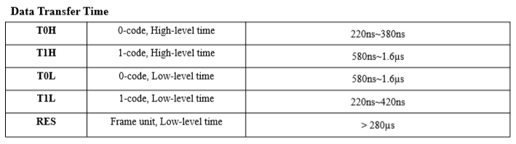

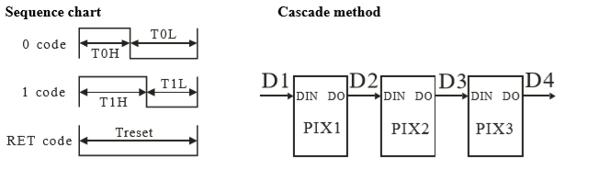
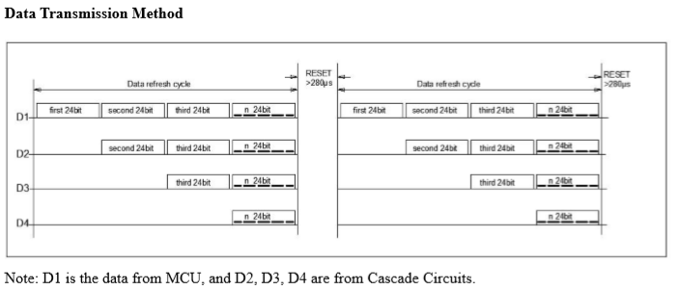
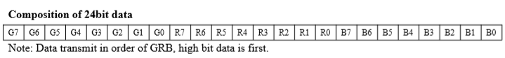

LED Module Dimension
The LED module realised as a 30x50 LED matrix.
The LED strip contains 30 LED/m. → 30 LED = 1m; 50 LED = 1,667m

Dimension:
- LED: 30x50 = 1500 LEDs
- Size: 1m x 1,667m

Data Connection NodeMCU LED Module
The NodeMCU is connected to the LED module via 6 GPIO ports.
Each GPIO port controls one LED lane.
A LED lane consists of 5 serial connected LED module rows → a LED lane contains 250 LEDs.
NodeMCU
LED Lane 1
1
2
50
GPIO1
LED Lane 2
LED Lane 3
LED Lane 4
LED Lane 5
LED Lane 6
GPIO2
GPIO3
GPIO4
GPIO5
GPIO6
1
2
3
4
5

